**Due Date: 21 November 2023**

**SIR SYED UNIVERSITY OF ENGINEERING & TECHNOLOGY**

**COMPUTER SCIENCE & INFORMATION TECHNOLOGY DEPARTMENT**

**Fall 2023**

**Parallel & Distributed Computing (CS-429)**

**Assignment # 1**

Semester: Batch:

Announced Date: Due Date:

Total Marks: Marks Obtained:

Instructor Name:

| **CLO #** | **Course Learning Outcomes (CLOs)** | **PLO Mapping** | **Bloom’s Taxonomy** |
| --- | --- | --- | --- |
| CLO 1 | **Demonstrate** the following program using GPU utilization in python. | PLO_1  (Academic Education) | C2  (Demonstrate) |

Q1. **Demonstrate** the following program using GPU utilization in python. Assignment must contain/cover the following points.

Note: Every group is designated a separate dataset ,please use in particular for simulation process.

**Dataset of G12:** <https://www.kaggle.com/datasets/alik05/forest-fire-dataset>

**Group Members:**  
**Muhammad Shayan Ashraf**

**BSCS -2020 -097**

**Muhammad Nouman Imran**

**BSCS -2020 -097**

**1-Abstract (450 words) one paragraph**

This dataset is meticulously crafted to tackle the challenge of forest fire detection, aiming to facilitate the development of an AI model capable of learning and predicting forest fire patterns. The dataset comprises exclusively 3-channeled images with a resolution of 250 × 250 pixels, retrieved through systematic searches across various engines using specific terms. Subsequently, a rigorous curation process is employed to scrutinize and cleanse the images, ensuring the removal of inappropriate elements such as people and fire-extinguishing machinery. This meticulous approach guarantees that each image exclusively contains the relevant fire region.

Designed for the binary problem of Fire and No-Fire detection in forest landscapes, the dataset is well-balanced, incorporating a total of 1900 images, evenly split with 950 images for each class. To facilitate model development and evaluation, the dataset is strategically divided into an 80:20 ratio for training and testing purposes in the proposed study.

The overarching goal is to employ the Keras framework to construct an AI model that learns and discerns patterns indicative of forest fires. The model will be trained on the curated dataset, leveraging the balanced distribution to enhance its ability to distinguish between fire and non-fire instances. The study aims to contribute to the advancement of forest fire detection methodologies, utilizing machine learning techniques to provide accurate and efficient predictions.  
  
**2-Detail of dataset (450 words) one paragraph**

This dataset is curated to address the forest fire detection problem. All images in the dataset are 3-channeled with resolution of 250 × 250. The images were retrieved by searching various search terms in multiple search engines. Afterwards, these images are thoroughly investigated to crop and remove the inappropriate components such as people, fire-extinguishing machinery etc in order to ensure that each image only contain the relevant fire region. The dataset is designed for binary problem of Fire and No-Fire detection in the forests landscape. It is a balanced dataset consisting of 1900 images in total, where 950 images belong to each class. The dataset is divided into 80:20 for training and testing purposes in the proposed study.

**3-Program must use auto split function to split dataset into 70, 15, 15 (Training, Testing, validation)**

**image_paths_train, image_paths_temp, labels_train, labels_temp = train_test_split(image_paths, labels, test_size=0.3, random_state=42)**

**image_paths_test, image_paths_valid, labels_test, labels_valid = train_test_split(image_paths_temp, labels_temp, test_size=0.5, random_state=42)**

**4-Base model e.g. VGG, Inception + Optimizer e.g. Adam, RMS prop) (as per your choice)**

model = tf.keras.Model(inputs, outputs, name="EfficientAttentioNet")

model.compile(

optimizer=keras.optimizers.Adam(

hp.Choice('learning_rate', values=[1e-4, 1e-5])),

loss='categorical_crossentropy',

metrics=['accuracy'])

**5-Precision, Recall, F1-Score, True Positives, False positives, True Negatives, False Negatives**

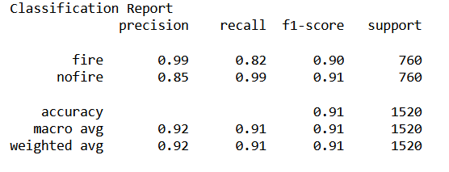

**6- Plot the training and validation accuracy graph**

**7- Plot the training and validation loss graph**

**8- Plot the confusion matrix for the training and Validation set.**

**9- Create a line plot graph for the number of images per class.**

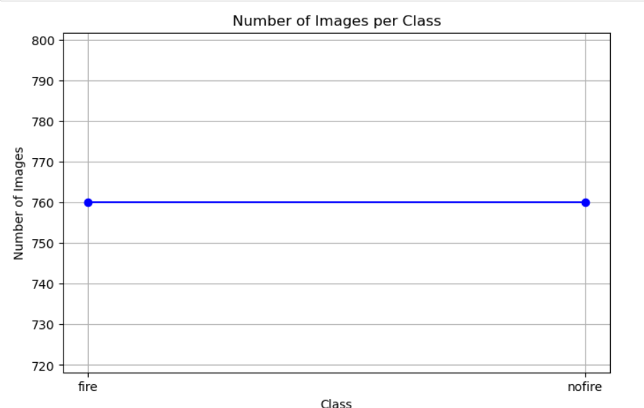

**10- Calculate ROC curves, AUC, and error rates for each class.**

****

**11- Calculate image counts graph/Number of images for each process e.g. testing, train, and validation.**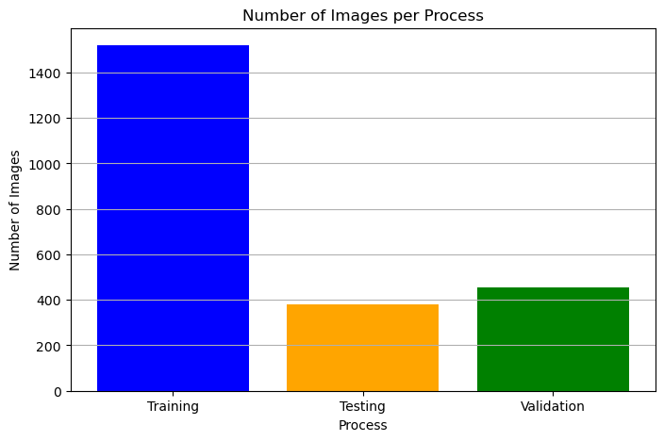

**----THE END----**